1. APP是一一对应

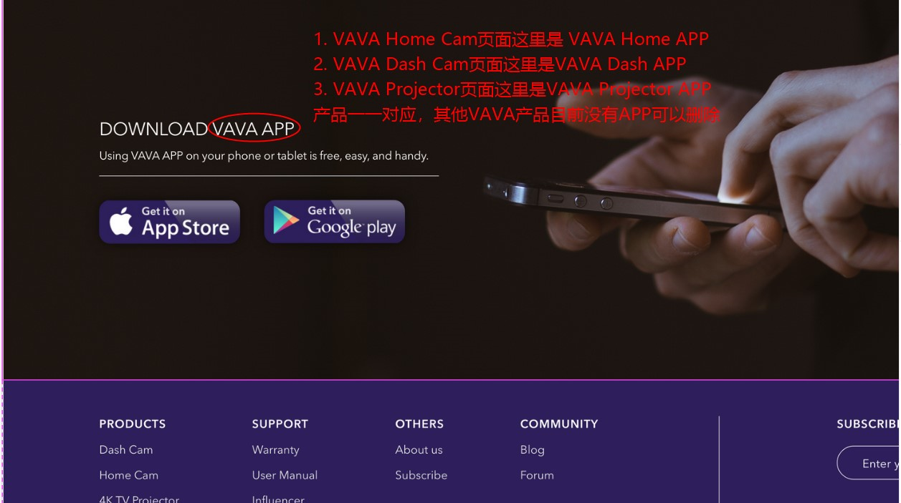

２.扫地机器人产品页面：

　去掉价格

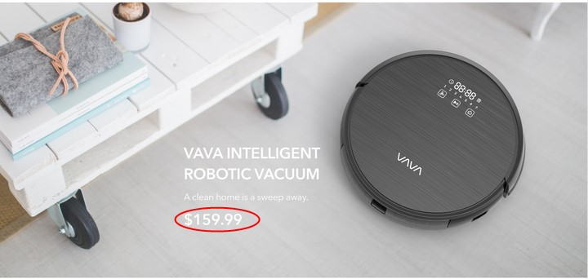

1. 扫地机器人文案替换：

Automatically returns to the charging when finished cleaning or running low on power to recharge and be ready for the next round．

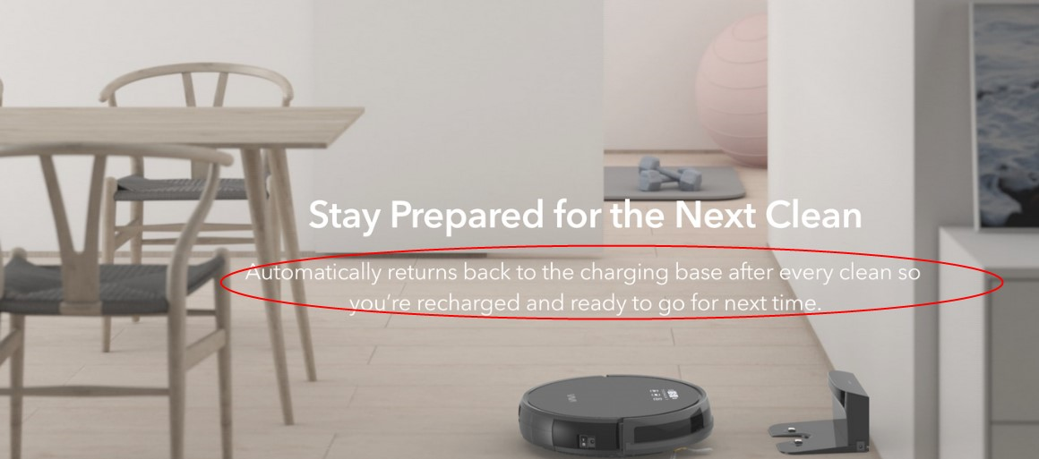

1. CD005 Dash Cam/ 2K dash

画面删除

